Project Design Phase
Solution Architecture

Date | 14 January 2026
Team ID | SWTID-2026-7310
Project Name | Auto Ticket Classification using Flow Designer
Maximum Marks | 4 Marks

Solution Architecture:
Solution architecture is a complex process – with many sub-processes – that bridges the gap between business problems and technology solutions. Its goals are to:
- Find the best tech solution to solve existing business problems.
- Describe the structure, characteristics, behavior, and other aspects of the software to project stakeholders.
- Define features, development phases, and solution requirements.
- Provide specifications according to which the solution is defined, managed, and delivered.

Solution Architecture Diagram - Auto Ticket Classification using Flow Designer:

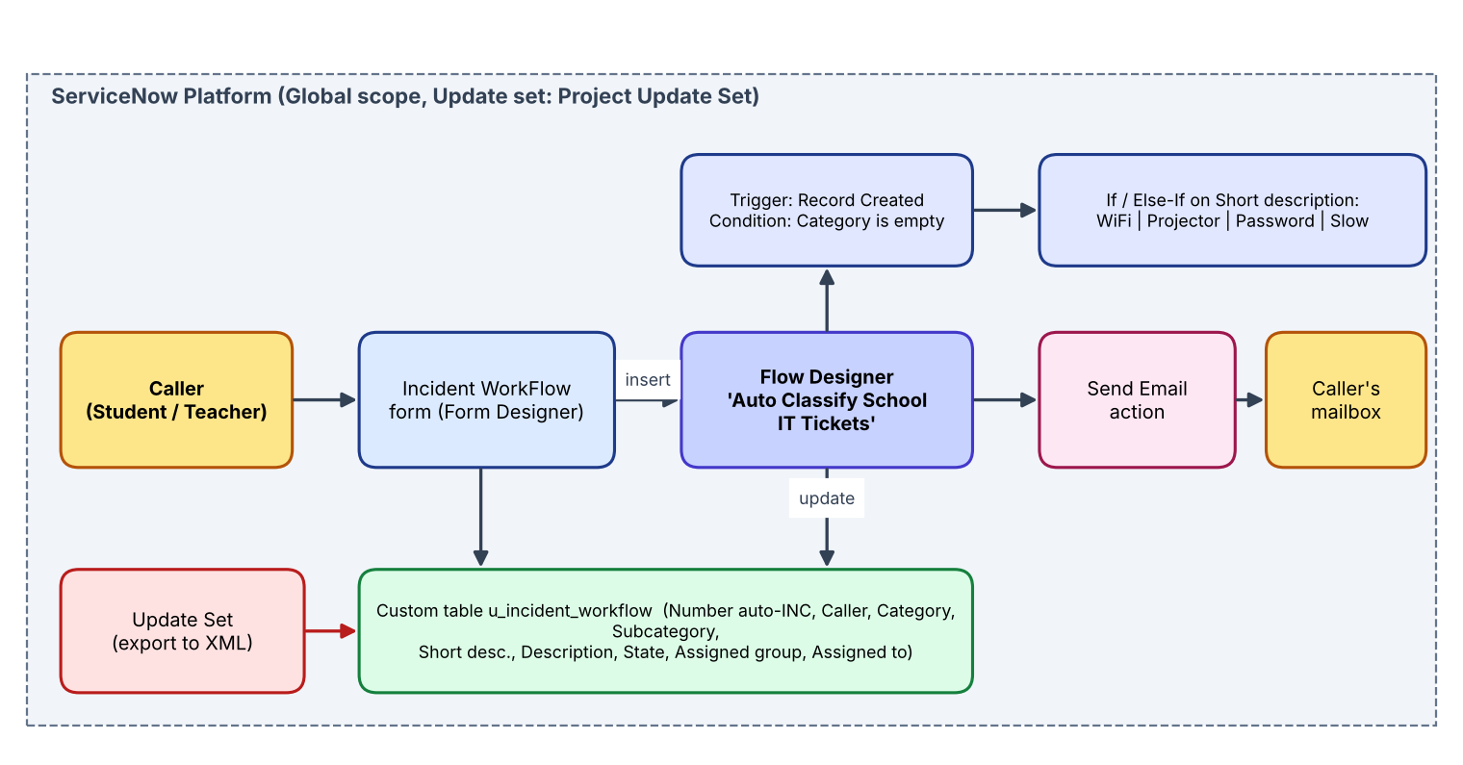
Figure 1: Architecture and data flow of the Auto Ticket Classification solution on ServiceNow
Data flow:
• The caller opens the Incident WorkFlow form and enters Caller and Short description; the record gets an automatic INC number.
• Record Created (Category is empty) triggers the flow 'Auto Classify School IT Tickets'.
• The flow evaluates the Short description with If / Else-If conditions and runs Update Record to set Category and Subcategory.
• The Send Email action mails the caller using the Caller > Email field; the mail is visible under System Logs > Emails.
• All configuration is captured in 'Project Update Set', set to Complete and exported as XML for deployment.

